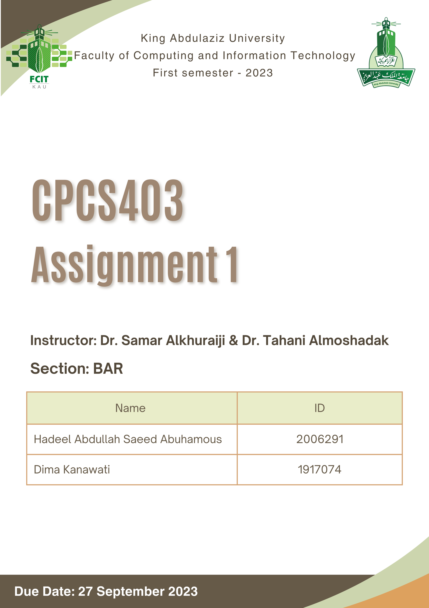

Table of Contents

Website 3

Project Idea 3

Recommended solution 3

Benefit 3

Storyboard 5

Sitemap 10

Table of Figures

[Figure 1 Sign Up page storyboard 5](https://kauksa-my.sharepoint.com/personal/1917074_stu_kau_edu_sa/Documents/CPCS403_Assignment1_Group3_Emaa.docx#_Toc146703011)

[Figure 2 Log In page storyboard 5](https://kauksa-my.sharepoint.com/personal/1917074_stu_kau_edu_sa/Documents/CPCS403_Assignment1_Group3_Emaa.docx#_Toc146703012)

[Figure 3 Homepage storyboard 6](https://kauksa-my.sharepoint.com/personal/1917074_stu_kau_edu_sa/Documents/CPCS403_Assignment1_Group3_Emaa.docx#_Toc146703013)

[Figure 4 Levels page storyboard 6](https://kauksa-my.sharepoint.com/personal/1917074_stu_kau_edu_sa/Documents/CPCS403_Assignment1_Group3_Emaa.docx#_Toc146703014)

[Figure 5 Learn page storyboard 7](https://kauksa-my.sharepoint.com/personal/1917074_stu_kau_edu_sa/Documents/CPCS403_Assignment1_Group3_Emaa.docx#_Toc146703015)

[Figure 6 Leaderboard page storyboard 7](https://kauksa-my.sharepoint.com/personal/1917074_stu_kau_edu_sa/Documents/CPCS403_Assignment1_Group3_Emaa.docx#_Toc146703016)

[Figure 7 Contact page storyboard 8](https://kauksa-my.sharepoint.com/personal/1917074_stu_kau_edu_sa/Documents/CPCS403_Assignment1_Group3_Emaa.docx#_Toc146703017)

[Figure 8 Quizzes page storyboard 8](https://kauksa-my.sharepoint.com/personal/1917074_stu_kau_edu_sa/Documents/CPCS403_Assignment1_Group3_Emaa.docx#_Toc146703018)

[Figure 9 Profile page storyboard 9](https://kauksa-my.sharepoint.com/personal/1917074_stu_kau_edu_sa/Documents/CPCS403_Assignment1_Group3_Emaa.docx#_Toc146703019)

[Figure 10 The sitemap of the website 10](https://kauksa-my.sharepoint.com/personal/1917074_stu_kau_edu_sa/Documents/CPCS403_Assignment1_Group3_Emaa.docx#_Toc146703020)

# Website

Website link: http://emaa.atwebpages.com/

# Project Idea

Our project is to provide a platform to learn Arabic sign language in an interactive, gamified manner. Tracking the user’s progress and reward when succeeding. This website is for everyone who wants to learn sign language. It’s easy to use and simple.

# Recommended solution

Since a few resources are available to learn Arabic Sign Language online, our website offers a simple and effective platform for learning Arabic Sign Language. It is designed to break the language into easy-to-understand sections, including basic alphabets, numbers, and commonly used words. The site provides structured lessons and interactive quizzes to help users test their knowledge. With varying difficulty levels and a dedicated progress-tracking feature, the website offers a comprehensive learning experience for anyone interested in sign language.

# Benefit

* Accessibility:

With limited resources available for Arabic Sign Language online, our platform fills a crucial gap, making learning accessible to everyone, anywhere.

* Structured Learning:

Learners can progress by categorizing lessons into foundational elements like alphabets, numbers, and phrases, ensuring a systematic and thorough understanding.

* Interactive Engagement:

The quizzes reinforce the knowledge and keep users engaged, making learning more enjoyable.

* Personalized Progress Tracking:

Users can monitor their learning journey, allowing them to identify areas of strength and those that need more practice. This personalization fosters a sense of achievement and motivation.

* Adaptable Difficulty Levels:

Catering to both novices and those with some foundational knowledge, the platform ensures that learners of all proficiencies find content suited to their skill level, ensuring sustained interest and growth.

* Comprehensive Resource:

It's not just about teaching signs; it's about instilling confidence in users. With a well-rounded approach, learners have all they need in one place, negating the need to juggle multiple resources.

* Promotion of Inclusive Communication:

By providing this platform, more individuals can communicate effectively with the deaf and hard-of-hearing community, bridging communication gaps and promoting inclusivity.

# A screen shot of a login screen Description automatically generatedStoryboard

Figure 1 Sign Up page storyboard

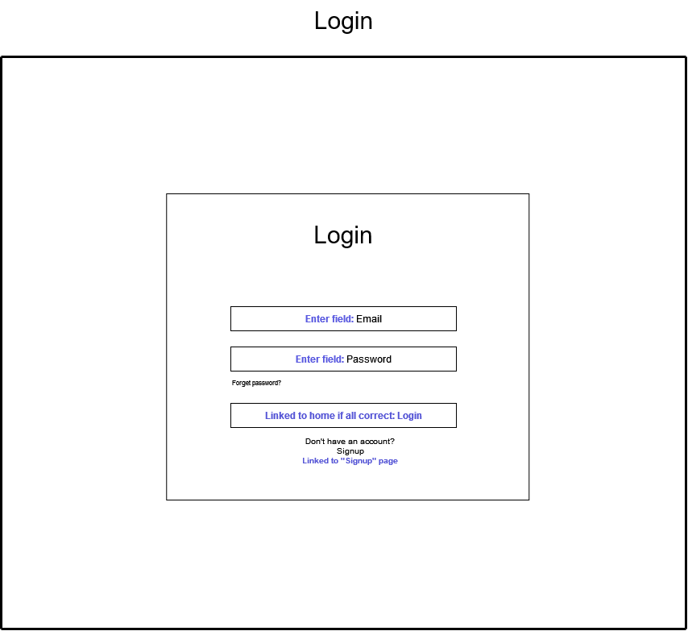

Figure 2 Log In page storyboard

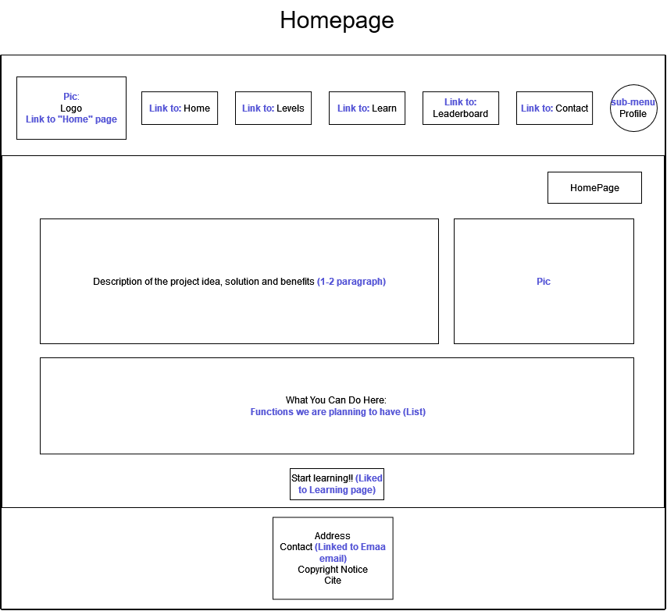

Figure 3 Homepage storyboard

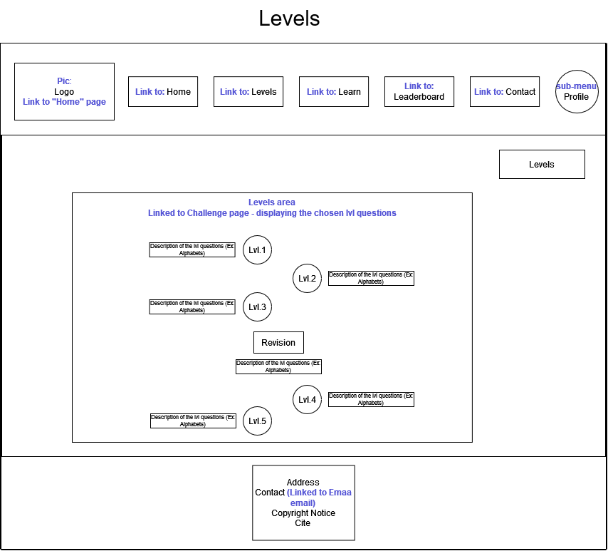

Figure 4 Levels page storyboard

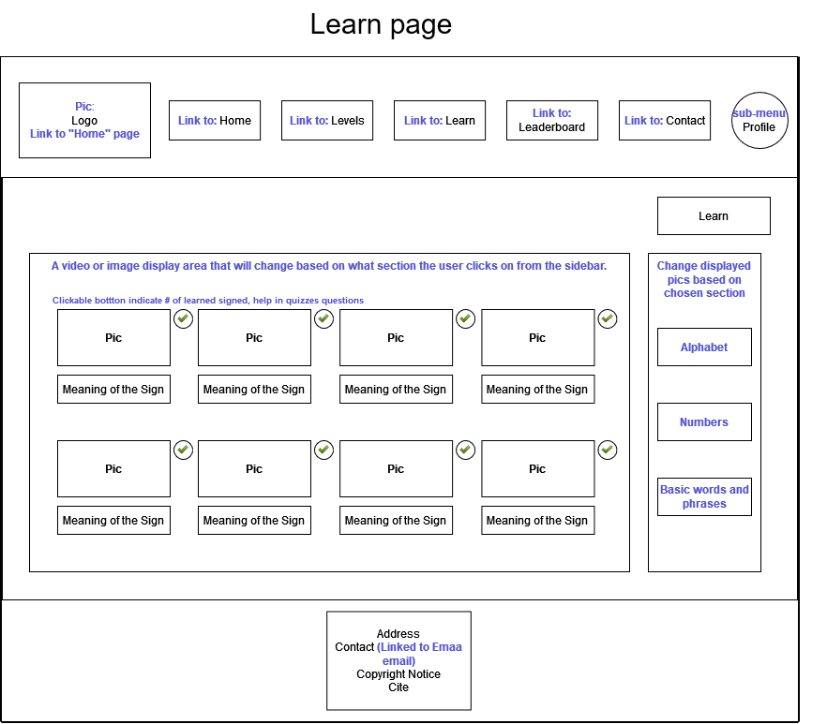

Figure 5 Learn page storyboard

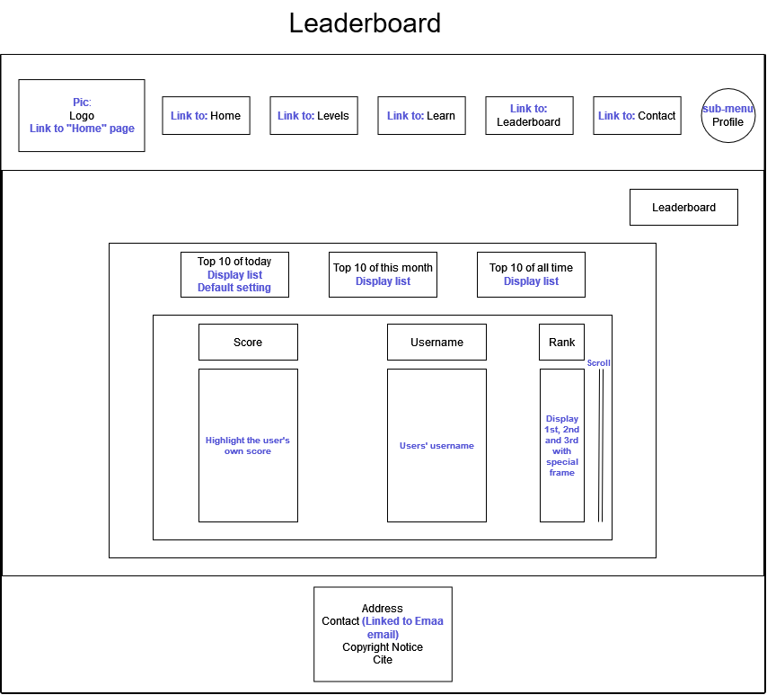

Figure 6 Leaderboard page storyboard

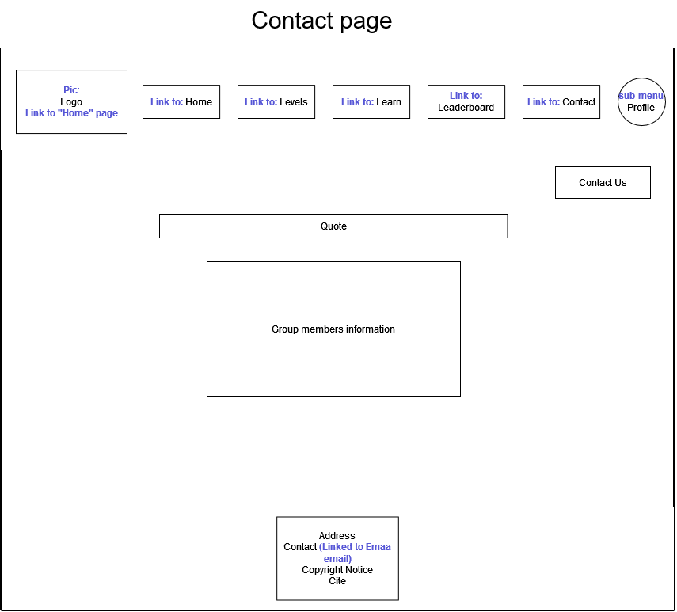

Figure 7 Contact page storyboard

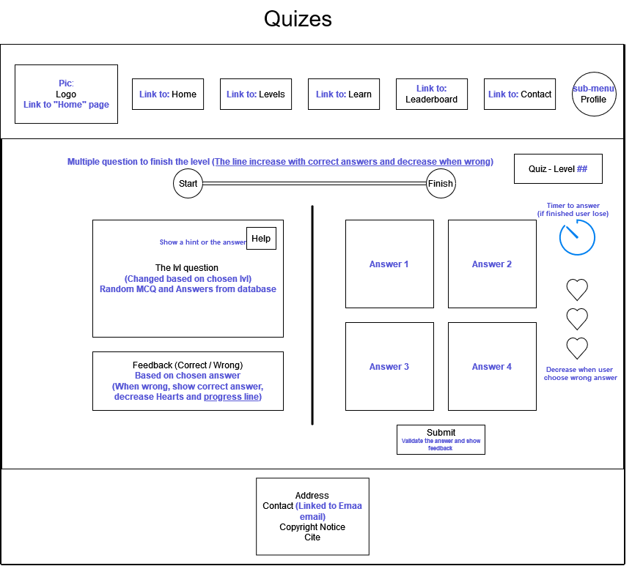

Figure 8 Quizzes page storyboard

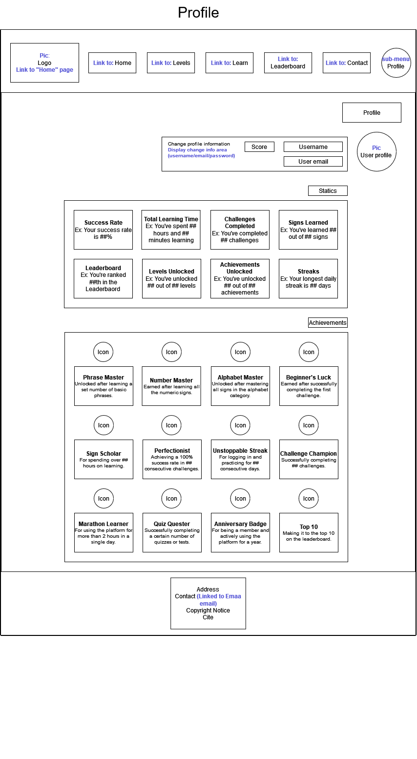

Figure 9 Profile page storyboard

# Sitemap

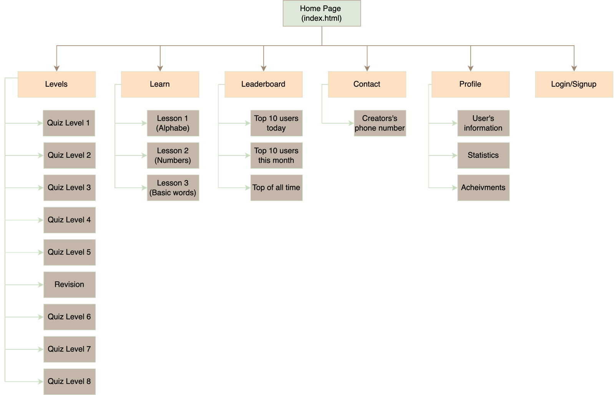

Figure 10 The sitemap of the website